City Lights version 1.3

##### *Unity Version: 2019.2.4f1*

*Game Design Document*

**Contents**

Game Design 2

Summary 2

Story 2

Gameplay 2

Mindset 3

Technical 4

Screens 4

Controls 4

Mechanics 4

Player Upgrades 6

Upgrade Types 6

Level Design 7

Themes 7

Game Mockup 8

Game Flow 9

Graphics 10

Style Attributes 10

Graphics Included 12

Sounds/Music 13

Style Attributes 13

Sounds Needed 13

Music Needed 14

Schedule 15

Development Timeline 15

Playtesting 18

Test Strategy and Goals 18

Playtest Notes 18

Roles/Credits 19

# Game Design

## Summary

You are one of Brightnyte’s Fireflyters. Your job is to venture into the forest each night, using your vacu-lamp to collect fireflies while dodging the shades that seek to steal your light from you. Gathered fireflies will work to keep Brightnyte alight during the night, while extra fireflies can be spent to power up your vacu-lamp and collect more fireflies each night.

## Story

Welcome to Brightnyte, a burgeoning city situated on the edge of Firefly Forest. Here, daily life is a joyous, bustling thing. So long as there is light in the sky, denizens make their livings in a manner of different ways. But, come nighttime, doors lock, and shutters slam closed, for it is during the night that the Shades roam free. Dastardly creatures of little discernible intelligence, Shades move through the night with never-ending hunger, feeding on any creature they come across. Unable to stand the pain from any source of light, they roam the land seeking prey without the necessary illumination to protect them. That is why it is of the utmost importance that every night, Brightnyte’s firefly-powered lanterns light the streets, protecting the city and its inhabitants from the danger that the shades represent. As one of the city’s newest Fireflyters, it is your job to venture outside the city each night and collect fireflies to bring back and illuminate the city. With your trusty vacu-lamp by your side, you must travel deep into the forest, searching for fireflies of varying luminescence. But, beware, the path is not one of safety and comfort. As you travel, forest spiders and shades will lurk in the shadows, waiting for an opportunity to wrench your protective light from you. Make it back unscathed and the fireflies you’ve collected will prepare Brightnyte’s buildings for their next dangerous evening. You are even welcome to keep any extra fireflies that you gather. After all, vacu-lamp adjustments go for quite a few fireflies on the local market. Best of luck, young Fireflyter. Please keep in mind, the city is depending on you.

## Gameplay

This is a 2.5D dodging/collection/upgrade game. There are two zones to this game: forest and city. In the forest, you are working to collect fireflies with your vacu-lamp while simultaneously dodging the shades that attack you. The number of fireflies in your inventory will determine how far around you that you can see. The layout of the forest is in concentric rings, with further rings from the center (the city) holding better value fireflies as well as more shades. Each night that you step out into the forest, your firefly goal will be based around a particular city building that you seek to light, with any fireflies over your building goal going into your wallet. In the city, you can approach the upgrade stall to upgrade different aspects of your character, whether that be vacu-lamp strength or running speed. These upgrades will be purchased with the excess fireflies that went into your wallet. Additionally, the city will be the location in which you approach the Fireflyter chief regarding the next building that you must light. The end goal of the game is to light up the entire city, meaning that the gameplay will consist of back and forth entering the city for upgrades and entering the forest to collect fireflies until such time that all city buildings are well lit.

## Mindset

The mindset that we will seek to provoke in the player is one of slight unease as well as fear of the unknown. While in the city, music and art style will be brighter and calmer, but in the forest the music and art style will work to hurry the player as their situation becomes progressively urgent. The lack of obvious direction in the forest will also provide an adventurous side to the gameplay. In order to provoke these emotions, we will make use of the game’s sound, art, and mechanics. With sound, environment dependent music as well as haunting sound effects as a result of an action will set the mood. With art, darker colors will be used in the forest to lend the environment a spookier look, while brighter colors in the city will make the player feel a bit safer. As for mechanics, two specific ones will be most important in affecting player mindset: AI response to nearby player and limited field of view based on fireflies in inventory. Both shades reacting to attack you when you near them and a limited field of view will make the player feel rushed and afraid.

# Technical

## Screens

1. Title Screen
   1. Play
      1. Save Select
   2. Options
   3. Credits
   4. Exit
2. Game
   1. Forest
      1. Forest Floor
      2. Post-Level Scoring
   2. City
      1. Street
      2. Upgrade Stall
      3. Building Goal Description (Mayor’s Office)

## Controls

|  |  |  |  |  |  |  |
| --- | --- | --- | --- | --- | --- | --- |
| **Walk** | **Activate vacu-lamp** | **Aim vacu-lamp** | **Interact** | **Select** | **Activate ability** | **Pause game** |
| WASD | Left mouse click | Mouse movement | E | Space | Q | Esc/P |

## Mechanics

* *Fireflies* - semi-random movement, avoiding obstacles (can go over rocks, but not trees)
* *Firefly Collection* - player must suck up fireflies which spawn randomly in different densities per zone
* *Spider Eating Fireflies* - player may encounter spiders on the ground or in spider webs. When running into the spider, it will eat a set number (depending on testing) of the player’s collected fireflies
* *Equipment Upgrades* - Player can upgrade various abilities using excess fireflies
* *Level Timer:* Shows the player the amount of time they have left before “Shadow hour” begins after a set amount of time passes. The player can continue as long as they wish, but the game gets harder and harder as progressively more enemies spawn as time goes on.
* *City* – Upon returning to the city, Buildings light up when filled with fireflies after meeting the given mission requirements by the Fireflyter Chief. The city will serve as a neutral zone in between firefly collections, and will feature different buildings for the player to visit:
  + *Fireflyter Station:* Player can visit this building to find out their next mission and check progress.
  + *Upgrade Shop:* Player can visit this building to upgrade their abilities with excess fireflies.
* *Enemy Attacks* - The player must avoid enemies while returning with their fireflies. Enemies will follow player once they’re in proximity and respond with a different attack pattern based on their type.
  + Shade 1: “Lunge” type of attack pattern (coil back, then surge forward.) When the player enters within its range, it will reel back and then linearly launch itself at the player with great speed. In between lunges, there will be a cooldown for a set number of seconds.
  + Shade 2: Will shoot projectiles (only within a set distance of the player)
  + Shade 3: Will chase the player while they are looking away. This Shade is fast and will stop moving when the player is looking in their direction.

Maps are generated from a selection of unique and mutable zones on game start to allow the player the satisfaction of learning the area throughout play. These may be changed via random event but will be mostly static on each save. The city is in the center of this map, with the distance measured in zones defining firefly rarity and spawn rate.

## Player Upgrades

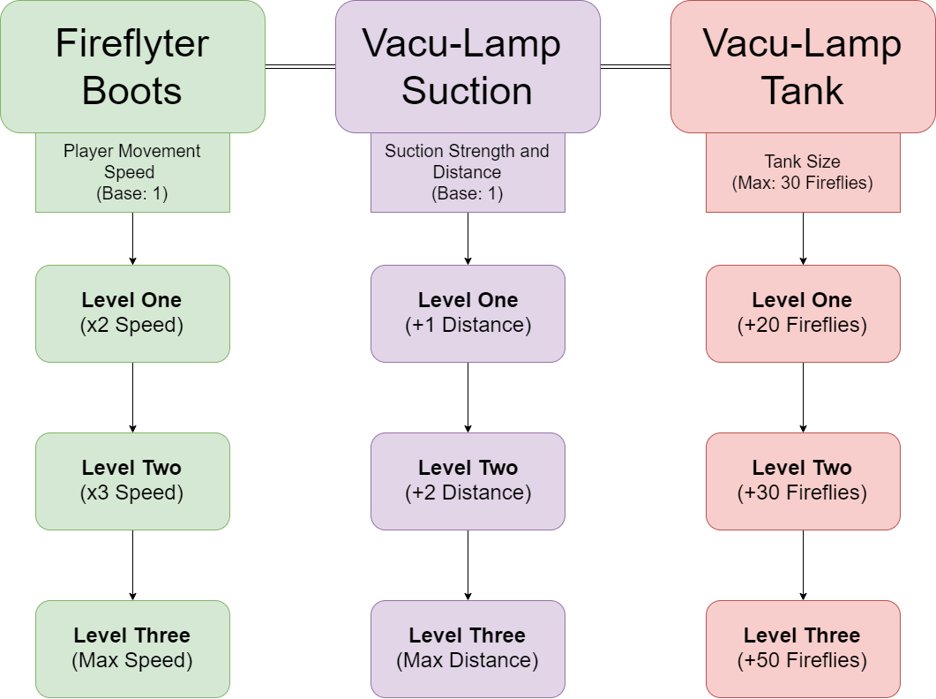

### Upgrade Types

*Fireflyter Boots*

Boosts movement speed enabling the player to dodge enemies more easily and to navigate the different forest zones faster. This can allow the player to collect fireflies faster before the timer expires and enemies spawn.

*Vacu-Lamp Suction*

Increases the suction strength and distance of the vacu-lamp. This enables the player to suck up fireflies from farther away, and to suck up higher-tiered fireflies faster.

*Vacu-Lamp Tank*

Increases the storage capacity of the vacu-lamp, allowing the player to store more fireflies per collection mission. This enables the player to take on larger building missions and provides the player with additional flexibility in losing fireflies to enemies.

*Shade Barrier*

The Shade Barrier equips the player with top of the line Fireflyter equipment providing a barrier to Shade attacks. The first upgrade tier provides the initial installation of the equipment and gives an immunity to the first attack from a Shade. The next tiers provide natural damage resistance to Shades following the first attack, reducing the penalty of fireflies lost from each attack.

# Level Design

## Themes

1. Town
   1. Mood
      1. Calm, cute, soft, always dusk
   2. Objects
      1. *Ambient*
         1. Buildings (illuminated and non)
         2. Lamp posts
         3. Benches
      2. *Interactive*
         1. Town Gates
         2. Fire Chief & Town Mayor
         3. Upgrade Shop
2. Forest
   1. Mood
      1. Slight unease, dark, urgent, sense of hope (due to the increase in light from firefly collection)
   2. Objects
      1. *Ambient*
         1. Landmarks
         2. Trees
         3. Mushrooms
         4. Snails
         5. Grass
         6. Flowers
         7. Tutorial Signs
      2. *Interactive*
         1. Fireflies
         2. Spiders / Spider Webs
         3. Shades

## Game Mockup

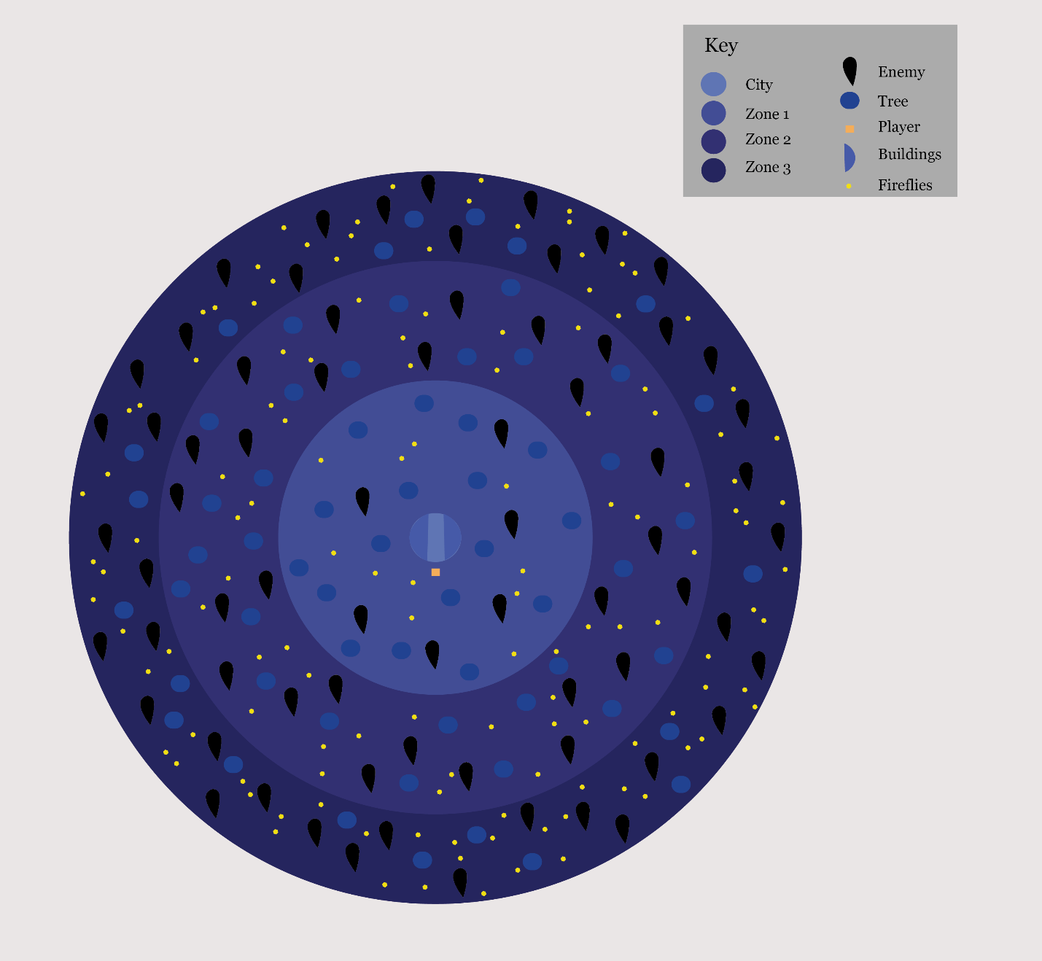

## Game Flow

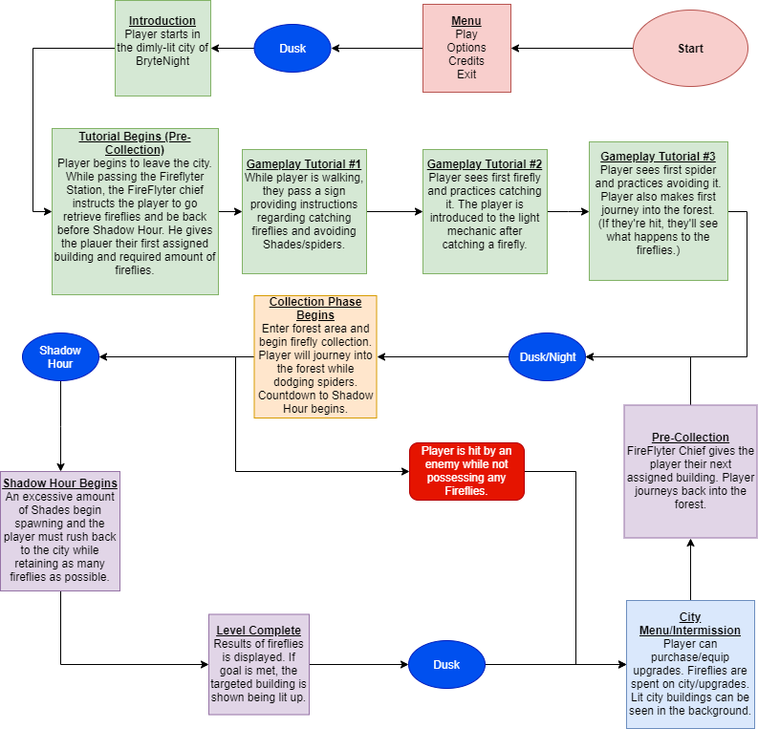

Development

# Graphics

## Style Attributes

We will be using a limited palette, including yellow, yellow orange, minimal pink, violet, and blue violet.

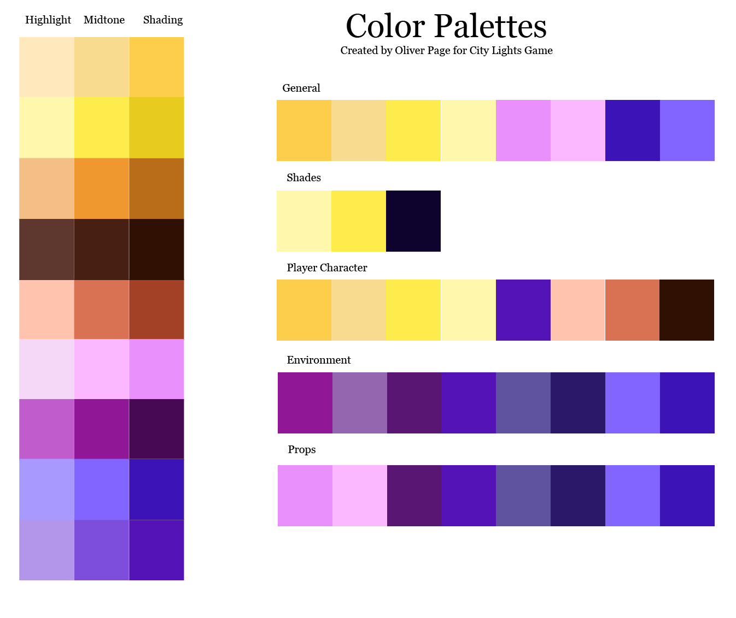

Character design will use cute, round shape language. References include *Adventure Time* and *Night in the Woods*. The main character will be an ambiguous gendered blob/chibi style character. They will have a simplistic design, very soft/rounded edges with a firefighter style jacket and hat. The vacu-lamp will be round as well (based off Gigie’s design,) with a more organic material for the tube. The fireflies will be depicted as simple circles with an aura of light around them in a few different colors. Characters and objects will have colored outlines (using overlay layers) with cell shading. The environment will have a more angular design, though edges will still be rounded. The city will have more round shape language, while the forest will use more triangular/square shape language.

The environment will be dark blues and purples, low saturation and soft hues: cool tone colors. The characters and the town will be warm colors, yellows, oranges, and peach/pink tones. Again, low saturation but slightly higher than the environment to create contrast.

We will have simple VFX animations when the player sucks up fireflies and when the player sucks up spiders or gets hit by enemies. There will be alerts on screen when enemies are nearby. When a player approaches an interactable object/building (aside from fireflies/enemies), UI will pop up instructing them to use the interact key.

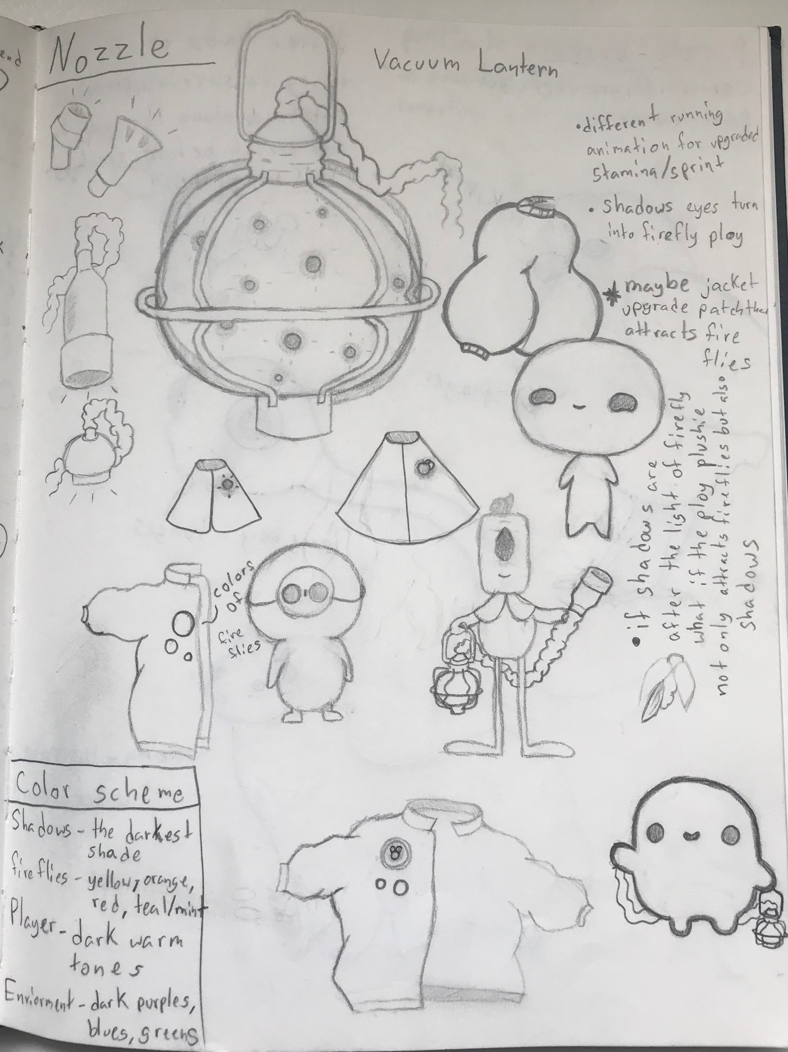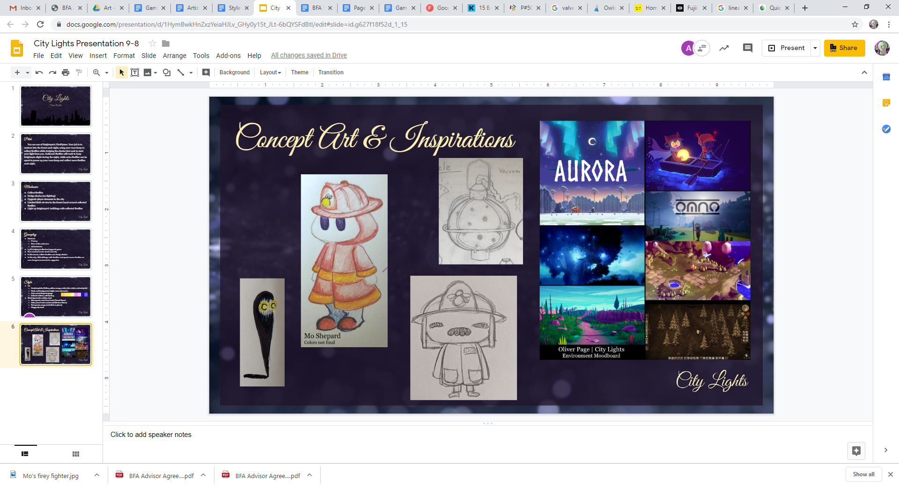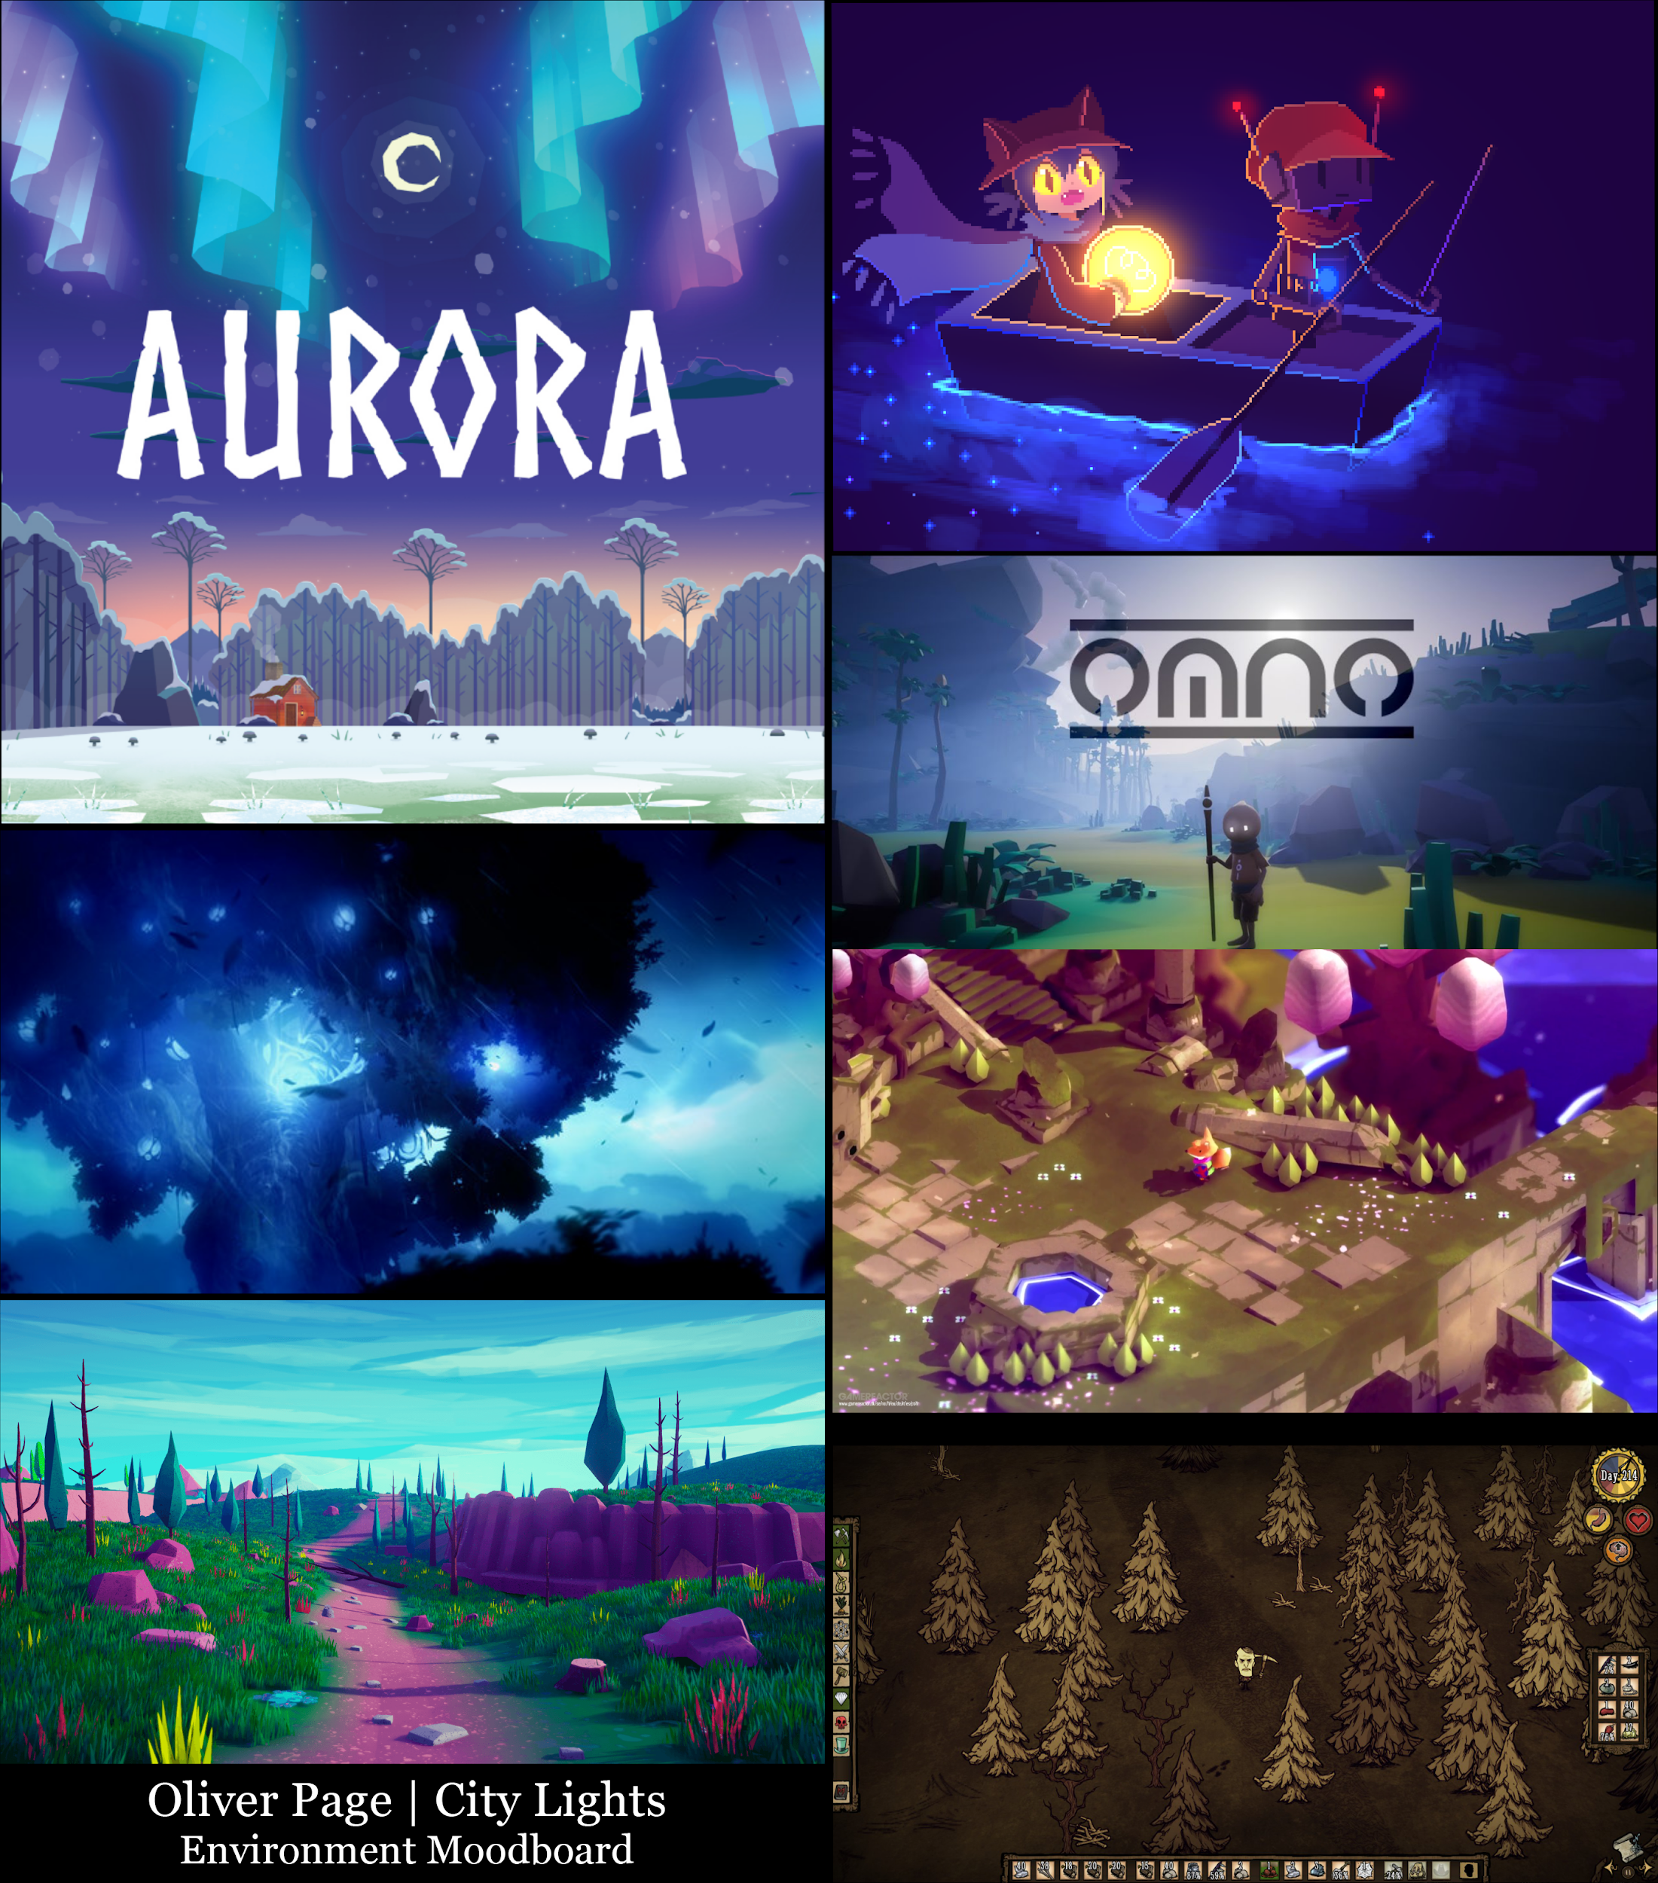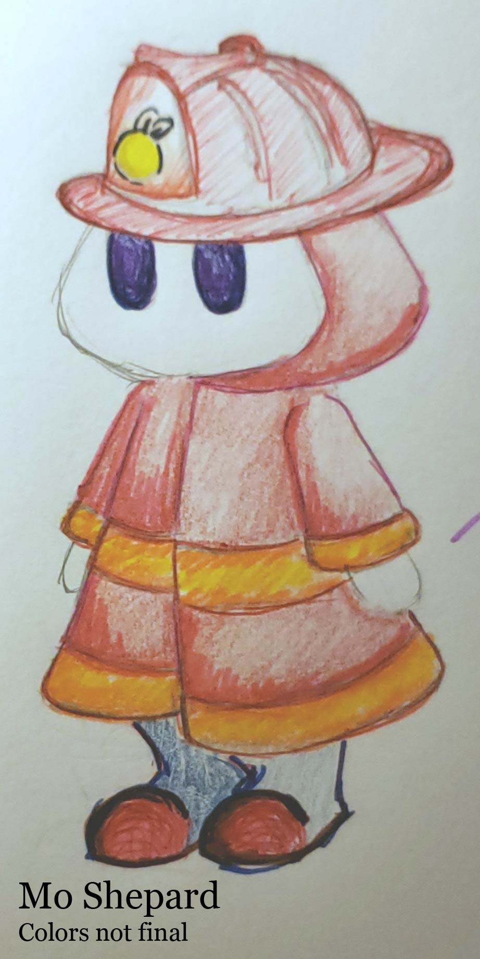

## Graphics Included

1. Characters
   1. FireFlyters
      1. Fireflyter: player (idle, walk, run, jump, take damage vacuum suck)
      2. Fireflyter Chief (idle)
   2. Fireflies
      1. Normal
      2. Rare
   3. Shades
      1. Shade 1 (idle, walking, attacking)
      2. Shade 2(idle, walking, attacking)
      3. Shade 3(idle, walking, attacking)
2. Tiles
   1. Dirt
   2. Grass
   3. Pond
   4. Special Area
   5. City Ground
3. Ambient
   1. Tall Grass
   2. Lamp Posts
   3. Trees
   4. Rocks
   5. Landmarks
4. Other
   1. City Gate
   2. City Wall (matching City Gate)
   3. General City Buildings
   4. Fireflyter Station
   5. City Upgrade Building
5. Buttons
   1. Menu Backgrounds
   2. VFX (sucking, getting a firefly, sucking up spiders, getting hit)
   3. UI (interact visual prompt)
   4. Cosmetic Upgrades for Character

# Sounds/Music

## Style Attributes

We’re going for cute, but also eerie and spooky, and we will use a lot of jazzy rhythms and ideas

like chromaticism. Poppy instruments, like piano, synths, horns, 808’s, but keep everything

wobbly and weird with nice detuning. Taking style influences from Animal Crossing, C418

(Minecraft), the beat to Paranoia by Chance the Rapper (has a great wobbly synth), Black Moth

Super Rainbow, and Stevie Wonder. Everything is going to have a soft warm tone and feel

really lush..

## Sounds Needed

1. Effects
   1. Footsteps (Forest)
   2. Jumping (Grunt)
   3. Landing (sticks/leaves)
   4. Firefly Flying (Slight buzzing/cricking when lit)
   5. Firefly Vacuumed
   6. Spiders (Footsteps or screeching)
   7. Shades (Idle growing)
   8. Shades Attacking (Slight roar)
   9. Fireflyter Chief (Muffled talking)
2. Feedback
   1. Fireflyter Cheer (Level complete or building lit)
   2. Fireflyter Secondary Cheer (Upgrade applied)
   3. Shocked “Ooomph!” (attacked)
   4. Happy Buzzing (building lit)
   5. Sad Sigh (Fireflies lost)
   6. Chimes (Menu navigation)
   7. Buzz/Secondary Chime (Menu Select)

## Music Needed

*Sound Composer Notes*

1. **Calm, forest track variation (Collection Phase)**

So I actually want this and the creepy track to be the same song   
I want this to be more ambient than the city track but it’s still gonna have a melody  
on the collection part I want it to start in the key of GMaj.  
and then there’ll be a transitional riff of some sort that changes it into the return phase  
I want soft sounds, like flutes, triangle wave synth, upright bass, marimbas  
this will be a cutesy track.

**Fast-Paced, Creepy Track (Return Phase)**

After the transition I’m going to bring in tom drums and violins. As well as the toms, I’m going to sample a clock as hi hats.  
I’m going to start it on the key of Emin (relative minor of G) and then go down the keys getting darker and darker. Each key, I will be increasing the bpm faster and making the drums louder to increase the tension and spookiness of trying to get back.   
I’m also going to play with tape distortion to make it wobbly and creepy.

1. **Happy city track**  
   Key of Bmaj, lots of chromaticism, very jazzy, lots of swing.   
   gonna have a cute drum track behind it, lots of hi hat, dum dis da-dum

Going to fill this track with some nice deep horns, xylophones, piano, and windchimes.   
My mom has a bunch of nice windchimes hanging up, so I’m going to record a bunch of samples of those it’ll be beautiful. <3

1. **Menu Track**Variant of the city track, but simpler tonally.

# Schedule

## Development Timeline

**(*Weeks Begin on the First Tuesday Class)***

**Week 2 (9/03)**

* Concept Finalization
* Fleshing out Mechanics
* Conceptualizing Aesthetics and Design

**Week 3 (9/10)**

* Game Design Document Drafted
* Aesthetics/Design Finalized
* Initial Production of Assets
* Finalization of Programming Roles
* Game Mechanics Finalized

**Week 4 (9/17)**

* Concept Art Finalized and implemented into the design document
* Main character stationary sprites created
* Enemy character stationary sprites created
* Environment objects drafted
* Initial sound effects created
* Game scripts drafted:
  + Basic mechanics
  + Player movement

**Week 5 (9/24) [Reflects 9/23 Revision]**

* Paper Game Mockup | Oliver and Griffin
* Prototype Construction Begins
  + Player Base Mechanics | Trey & William
    - Player Movement Behavior | Trey
    - Player Idle Animation | Mo
    - Player Lighting Mechanics | Trey
    - Vacu-Lamp Mechanics | William
  + Enemy Behavior and Generation | Sean & William
    - Enemy AI Script | Sean
    - Base Shade Stats | Sean
  + Basic Sprites Created | Gigie
    - Shade Sprites | Gigi
    - Player Sprites | Pristine & Sally
  + Conceptualizing Zone Generation | Griffin, Kevin & Oliver
    - Zone Mapping | Griffin
    - Zone Generation Script | Kevin
    - Tile Art Design | Oliver
  + UI Base Functionality | Arik & George
    - Main Menu | Arik
    - Pause Menu | George
    - Options Menu | Arik & George
    - Upgrades Menu/Overlay | Arik
    - In-Game UI | George
  + Upgrade Mechanics | Arik & Griffin
    - Upgrade Level Roadmap | Arik
    - Upgrade Framework & Script | Griffin & Arik

**Week 6 (10/1)**

* Merging Branches and Scenes into Base Playable Demo
  + Base UI Integration | George and Arik
  + Player Mechanics Integration | Trey and William
* Background Music & Sound FX Implementation | Austin

**Week 7 (10/8)**

* Character Movement Animations | Mo
  + Character Sprites Finalized | Pristine and Sally
* Menu Sprites and Design Implemented | Arik, George, & Gigi
  + Menu Sprites Complete | Gigi
  + Sprites Implemented into Menus | Arik & George
* Implementing Art Assets into Demo | Mo, Oliver, & Dev Team
* Demo Testing and Debugging | Dev Team
* Midterm Presentation Design | Kevin, Austin, & Arik

**Week 8 (10/15)**

* **[Midterm Presentation]**

**-DRAFT OF POST-MIDTERM TIMELINE-**

**Week 9 (10/22)**

* [*Fall Break for CWRU Students]*
* Art refinement:
  + Environmental assets
  + Level props
  + Character Animations
* Level design tweaks

**Week 10 (10/29) – Dynamic Development**

* Project Self-Evaluation: Revisiting Goals and Target Progress
* Refining and integrating final UI elements
* Enemy Behavior and Types Finalized
* Dynamic World Generation Implemented
* Development of Player Upgrade Variants Begin

**Week 11 (11/5) – Core Mechanics**

* Implementation of Firefly Variants
* Game Logo Design
* Integrating Finalized Art Assets
* Finalization of Main City Features
* Player Upgrades Complete
* Playtesting new game demo
* Finalize and beginning integration of background music/sound FX

**Week 12 (11/12) – Art Implementation & Playtesting**

* Polishing final character animations and environment assets
* Continue playtesting and debugging
* Revising/finalizing all art assets
* Revising marketing materials
* Final release preparation
* Creating a rough draft of the itch.io page

**Week 13 (11/19) – Faculty Presentation and Revision**

* In-class demo to faculty
* Finalized Assets Integrated
* Updating itch.io page

**Week 14 (11/26) – Minor Bug Fixes, Playtesting, and Revision**

* [*Last regular class*]
* Revisions from faculty suggestions
* Update itch.io page
* Additional playtesting, debugging, and polishing

**Week 15 (12/3) – Final Showcase**

* *[No class for CIA (liberal arts exams)]*
* Game is released
* Reviewing final presentation slides

***-Week 16 (12/12 or 12/13): FINAL PRESENTATION-***

# Playtesting

## Test Strategy and Goals

Playtesting will be done in increments during the month of November using a range of beginner, casual, and hardcore gamers of different backgrounds. During playtesting, we will be examining and refining the following elements:

* Enemy spawn frequency and difficulty.
* Upgrade multipliers and balancing to ensure that upgrades are challenging to obtain, without being game breaking and making the game too easy to play.
* Shadow Hour timer including timer length, post-Shadow Hour spawn frequency, and required amount for firefly collection.
* Map navigation and the use for landmarks to assess how players can easily navigate the map and return to the city.
* Upgrade Shop Prices and how feasible it is to obtain a proper number of leftover fireflies to purchase desired upgrades, while also ensuring they aren’t overly easy to obtain.
* Additional minor upgrades/improvements to the overall player experience based on scope and incorporation of post-development stretch goals.

## Playtest Notes

(Rough Draft as of 11/18/2019)

Name: Brian Pokorny

Date: 11/4/19

Feedback: Keeping in mind that this is a WIP...

* Menu
  + Simplistic, but overall good design.
  + The text on the credits button looks like it’s too far to the right.
  + The transition from title to game is very abrupt. Maybe add a fade transition or something.
* Gameplay
  + The art looks great. Stylistically, reminds me of “Don’t Starve” but more colorful, almost papercraft-y
  + Having the “how to play” on a sign works, but it’s somewhat jarring and unnatural (maybe this is temporary, idk). An explanation as to why we need to catch fireflies would help, too. From a player perspective, I have no idea what I’m doing, or why I’m catching the fireflies.
  + Catching fireflies works most of the time (99%), but rarely the particles look like they should get a firefly but can’t
  + As it currently stands, the core gameplay loop is a bit too repetitive. Perhaps you could add a secondary right click ability, or more enemies, or something
  + Game freezes for 5-10 seconds when you hit the up arrow key, despite the fact the other arrow keys work fine
* Town
  + The panoramic design is nice, however I feel like Unity’s default skybox clashes a lot with the “sky” of the town
  + Music is pretty good here.
  + Having the game freeze when you switch from the town to the forest is also quite jarring. Consider a fade to black, then a switch. It would make the load transition seem much more natural.
  + Not entirely sure what to do on spawn
  + The text that says “Press E to enter the Forest” is too small. However, I am willing to chalk that up to playing on a higher resolution monitor (Unity does weird stuff with text on high definition monitors).
* Forest
  + Easy to get lost. If at any point you need to return to spawn, an arrow on the minimap would help immensely
  + The environment looks great. Really nailed the atmosphere
  + Red doesn’t really seem like the best colors for the bounds of the forest. Also, you can “stand” on the top boundry walls if you go right up next to it.
  + Music in the forest became somewhat grating after two or three loops
* UI/Other
  + Pause menu does not have a dedicated quit-to-menu or quit game button. Makes exiting the game kind of a hassle

Name: Conor Hernit

Date: 11/8/19

Feedback:

* tutorial should be included in starting town
* Add quit button to pause menu
* Esc does not bring up pause menu in town
* Southern wall blocks view if you are too close to it
* Model of old man in town has vague lines over his head where the edge of image would be
* Add counter to track # of fireflies collected
* Icon in top-left is unclear in purpose
* Spider should be able to face right
* Front of character can’t collect orbs. If you approach an orb from directly behind it will snap to just in front of the character without collecting. Range appears to be about 45 degrees from the center of the model in either direction with a reach of about one square where orbs snap to front.

Name: Tomislav Perkovic

Date: 11/10/19

Feedback:

* Space bar causes game to freeze for a few seconds
* Goal isn’t clear
* Texture on vacuum function is missing or broken
* Fireflies don’t always get picked up some instantly get sucked others don't
* Pause menu doesn’t fit the rest but I understand they’re wip
* Player moves faster than enemies so there’s no struggle. Speed up enemies or slow the player down
* The spider seems out of place style/art wise

Name: Chelsey Bryant

Date:  11/9/19

Feedback:

* Love the art, it’s very cute
* The world looks really good and the enemies are also cute
* Controls were a little bit unclear and the tutorial signs were had to read
* Some fireflies are hard to pick up, but became easier as I got used to it
* I don’t know what the pause menu is for and enemies were still spawning
* Enemies are pretty easy to outrun
* What is this spider? Lol
* Before having it explained, I wasn’t sure why I’m collecting fireflies or what to do with them. I’m also confused about what I should do in the city scene besides leave.
* Got a little lost while venturing far out into the forest

Name: Cross Montanez

Date: 11/8/19

Feedback:

* Not sure what more to do in city except a future upgrade shop
* Enemies are too easy making them less intimidating
* Easy to get lost
* Player slightly enters the wall on the edge of the world
* Game transitions strange
* Hard to pickup fireflies at moments
* Would prefer some kind of dialogue for the tutorial instead of signs
* So are the fireflies gonna move and get harder to catch?

Name: Jamal Gibson

Date: 11/9/19

Feedback:

* I don’t get the fireflyter chief but the art looks cool
* I love the design of the player character
* Fireflies spawning near the city make it a little easier to get the first batch
* The Shades are pretty slow and don’t come very often, pretty easy to dodge them
* Spider webs are a little annoying, especially since the spider just roams around the city
* What do I do in the city?
* Pause menu is broken
* Got a little lost while venturing throughout the forest. There should be more tutorials or background given in-game so I can play without being guided or having things explained to me in-person

Name: Toyin Olabode

Date: 11/9/19

Feedback:

* The main menu looks REALLY good, can’t wait to see the rest of the art
* All of the characters are pretty cute. I love how gender neutral the player is
* The tutorial signs weren’t very clear of the controls but I eventually figured it out
* The Shades are cute but pretty slow
* The pause menu doesn’t really do anything and it was hard to quit the game
* When I paused the game for a little bit, Shades were still spawning and found myself surrounded after I pushed resume
* Can’t wait for the upgrades and the rest of the art!

Name: Anthony Dulaney

Date: 11/11/19

Feedback:

* Main Menu looks pretty nice, really love the art
* The chief and player looks pretty weird, but I can dig it
* Is the chief supposed to do anything in the city? Or just dance in place?
* Am I supposed to do anything else in the city?
* The shadow enemies are nice but I wish there was a little variety in enemies. Would love to see something else that does more than chase you around.
* There should be a tutorial before you leave the city for the first time, as well as maybe a backstory.
* The controls are simple and I like that, they should probably be explained more or at a sub-screen of the main menu
* I’m curious what the upgrades are gonna look like? What will happen after the first level? Will there be additional enemies like I mentioned, or just more fireflies to catch? Would love to see the difficulty increase as I go on.

Name Aaron Estes

Date: 11/3/19

Feedback

* The City Lights game concept is unique and a fun idea.
* Fireflyter character is nice and looks professionally done.
* Graphics are colorful and uniform but could use more scenery.
* It is a little difficult to read the signs at the start of the game.
* Game play is smooth but could stand to be more challenging.
* I experimented with playing the game with one hand and was still able to avoid the shades and collect fireflies.
* It was interesting to see that while the game is paused the shades continue to spawn.
* Overall, it is a fun gaming experience.

Name: Seth McKenna

Date: 11/17/19

Feedback:

* The environment is really cute! The 3D modeled trees mesh well with the simple ground texture.
* I'm assuming menus are in the works so I won't comment on those. (Though, Where are your options and credits???)d
* Should be obvious when you lose a firefly/ take damages
* Text/box/etc in opening of game is too small. Make it take up more of the screen.
* Player movement/animation need to be paused in screens
* Extra would read better as "excess" in the popup intro.
* Space between lines of text needs to be increased
* Please put movement instructions in intro popup. Don't assume the player will default to wasd
* Why can I see the world boundaries...? That's really unclean and unpleasant for the player. Maybe for the forest add a line of trees so it looks like the forest is too dense to walk through? Idk about the city, maybe a gate?
* Make it so that objects in the environment cannot be randomly generated *on top of the instructions*
* Tell the player that the direction of the vaculamp follows the mouse. This was not obvious or told to the player
* *Add a damn quit button*

## Issues/Bugs to Still be Addressed from Playtesting

(As of 11/25/2019, Highlighted = resolved)

### UI

* Adding and completing final options menu (pause menu)
* Implementing credits screen (main menu)
* Optimizing text size for differing screen sizes
* Changing “extra” in intro screen to excess
* Fully fleshed out tutorial that includes button controls
* Removing or refining tutorial signs
* Cleaning up in-game timer and collection UI elements for better transparency on firefly count, vaculamp capacity, and remaining time before Shadow Hour

### Gameplay

* Better hit reaction from the player (making it obvious when fireflies are lost)
  + Implementing sound or visual reactions
* Balancing mission assignment and upgrade values to maintain the challenge of the game
* Pacing and gradually rolling out enemies and mechanics each level to minimize redundancy and keep collection phases refreshing
* Implementing remaining enemy types
* Implementing remaining upgradable skills
* Finalizing the direction/intention of the pause menu
  + Either having the animated pause and fixing spawning and all movement to adhere to it, or simply freezing the game
* Implementing final animations/art for the player and enemies
* Including final particles for the vaculamp

### Environment

* Optimizing and finalizing world generation and tiles
  + Placeholder generation is being used since current world generation causes extremely strenuous load times
* Implementing landmarks throughout the scene to avoid the player getting lost in the forest, especially when trying to return to the city
* Implement final city art, including post-mission lighting scenes to show the lighting of assigned building
* Modify the camera or implement art that will hide city and forest boundaries

# Roles/Credits

**Artists:**

**Austin | Art Lead**

Sound Design | Music | UI | 3D Design/Animation | Art Lead

**Oliver | Art Lead**

Concept Artist | Environment | 2D&3D Assets | Art Lead

**Mo**

 Concept Artist | Lead Animator | Story

**Pristine**

Concept Artist | Animator | Props | 2D&3D Assets

**Sally**

Concept Artist | Animator | Story | UI

**Gigie**

Concept Artist | UI

**Programmers:**

**Trey Starshak | Tech Lead**

Vacu-lamp mechanics | Player Control | Lighting VFX

**Sean Rivers**

Enemy Behavior | Enemy Types

**Griffin** **Rubin**

Map Generation | Lore Generation

**Arik** **Smith**

UI Implementation | Upgrade Mechanics | Fireflies | City

**Kevin** **Szmyd**

Map Generation

**George Vo**

 UI Implementation